# JS Advanced: Regular Exam - 07.07.19

Exam problems for the ["JavaScript Advanced" course @ SoftUni](https://softuni.bg/courses/js-advanced). Submit your solutions in the SoftUni Judge system at <https://judge.softuni.bg/Contests/Compete/Index/1715#0>.

# Problem 1. SoftDo (DOM Manipulation)

### Use the given skeleton to solve this problem.

### Note: You have NO permission to change directly the given HTML *(index.html file)*.

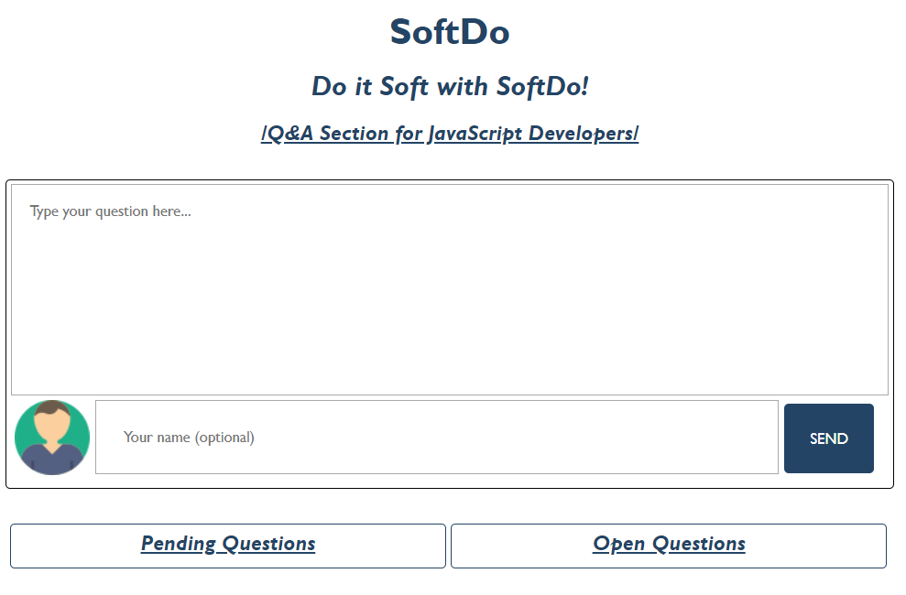

### Your Task

Write the missing JavaScript code to make the SoftDo application work as expected.

#### [Ask Question]

When the textarea *(Type your question here…)* is filled with some question and the button [**SEND**] is clicked, the current question should be displayed in the [**Pending** **Questions**] **section.** The input field for the username is **NOT required** - if it is filled, show the **given** **username** under the question, otherwise, the username is **Anonymous**.

##### [Ask Question as an Anonymous User *(input field is empty)]*

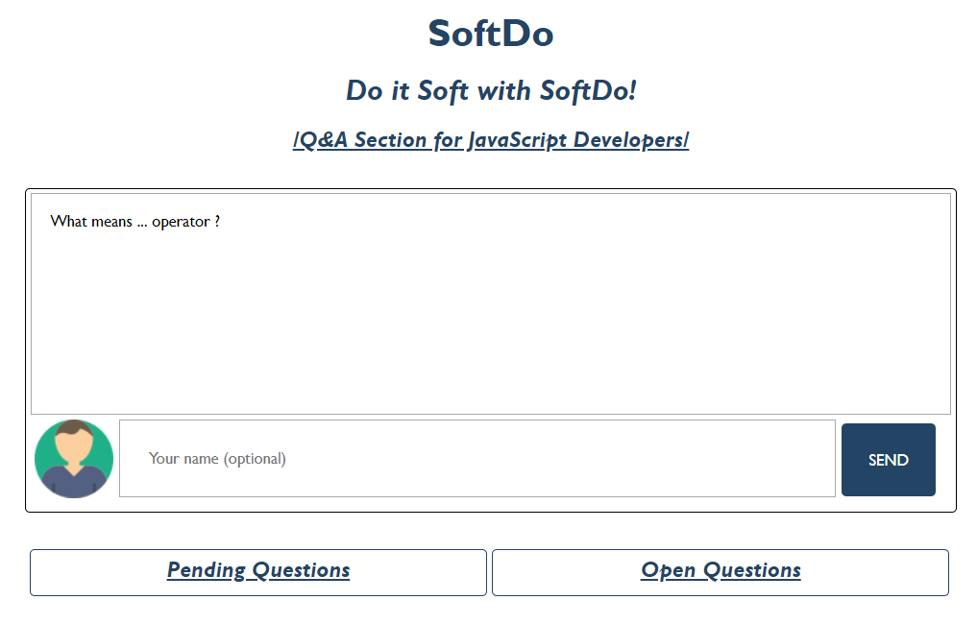

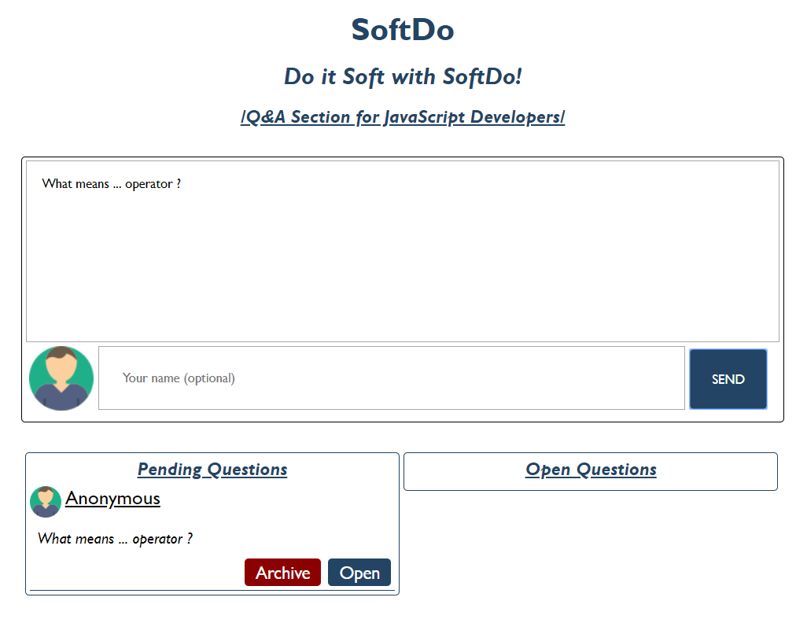

##### [Ask Question with Username *(input field is filled with some username)]*

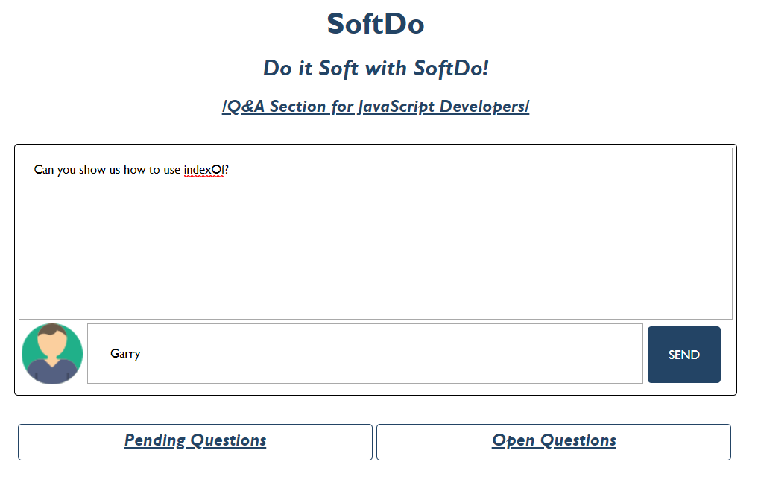

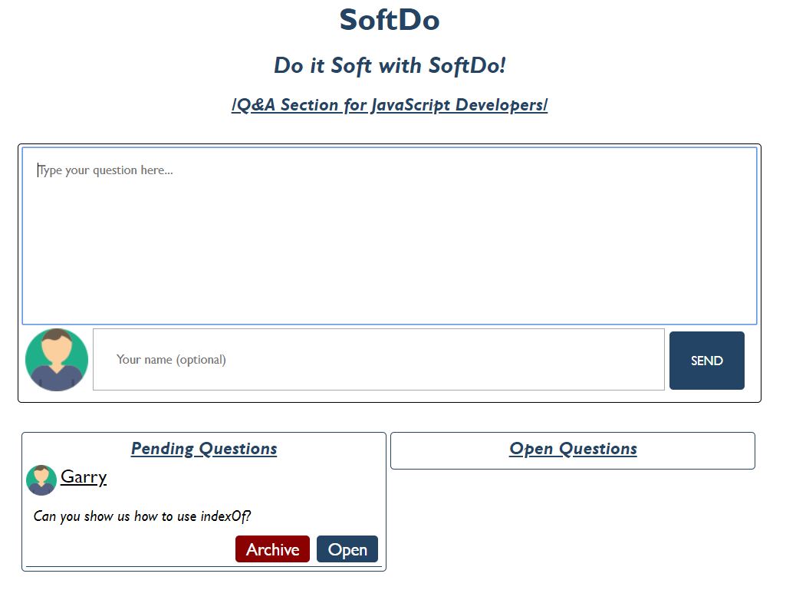

##### [Pending Question]

**Each** pending question:

* Children elements must be wrapped in a divelement with class "pendingQuestion"
  + First child is img which is same for every user (Anonymous or not). The user icon is provided in the skeleton resources (**images** **folder**). Each **img** should have **src**, **width** and **height** **attributes**.
  + Second child is a spanelementwhich holds the **username** (the given one from the input field or the Anonymous one).
  + Third child is а p **element**, which is the given question from the textarea.
  + The last (fourth child) is a divelementwith **class** "actions" which is а parent element of the two buttons ([Archive] and [Open])
    - [**Archive**] button has class "archive" and text content "Archive"
    - [**Open**] button has **class** "open"and text content "Open"
* Should be appended to the divwith id "pendingQuestions"

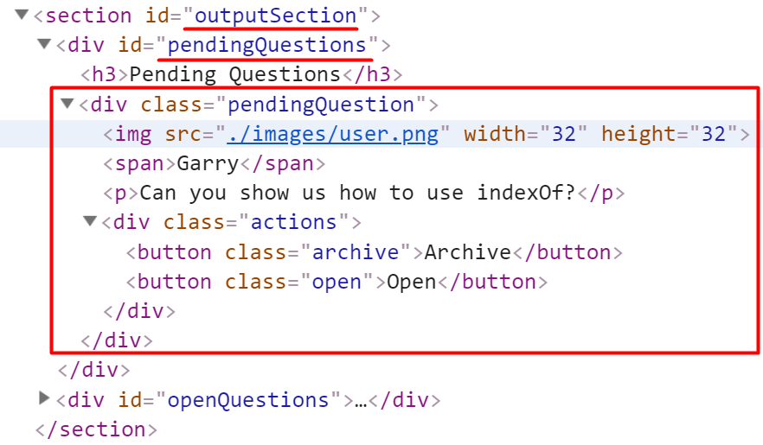

Clicking on the [**Archive**] **button** should **remove** the current question (divelement).

#### [Open Question]

If the [**Open**] **button** is clicked, the current question should be **moved (Append)** from the "pendingQuestions" section to the "openQuestions" section.

##### [Open a Question *(Moved from the [Pending] to the [Open] section)]*



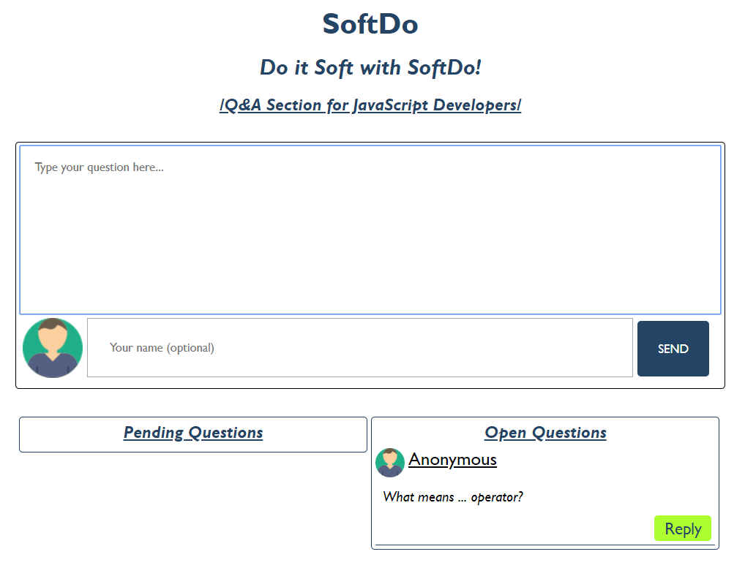

##### [Open Question Structure]

**Each** open question:

* Children elements must be wrapped in a **div element** with class "**openQuestion**"
  + First child is **img** which is same for every user (Anonymous or not). The user icon is provided in the skeleton resources (**images** **folder**). Each **img** should have **src**, **width** and **height** **attribute**
  + Second child is a **span element** which holds the **username** (the given one from the input field or the Anonymous one)
  + Third child is a **p element**, which is the given question from the **textarea**
  + Fourth child is a **div element** with **class** "**actions**" which is a parent element of the [**Reply**] **button**
    - [**Reply**] **button** has **class** "**reply"** and text content "**Reply**"
  + The last child here is a **div** **element** with class "**replySection**" which is a parent element of the **input**, **button** and **ol** elements:
    - **Input** **element** should have **class** "**replyInput**", **type** "**text**" and **placeholder** "**Reply to this question here...**" Set in that order!
    - **Button** element should have **class** "**replyButton**" and text content "**Send**"
    - Theorderedlist **(ol element)** should **two** attributes (**class** "**reply**" and **type** "**1**") Set in that order!
* Should be appended to the **div** with id "**openQuestions**"

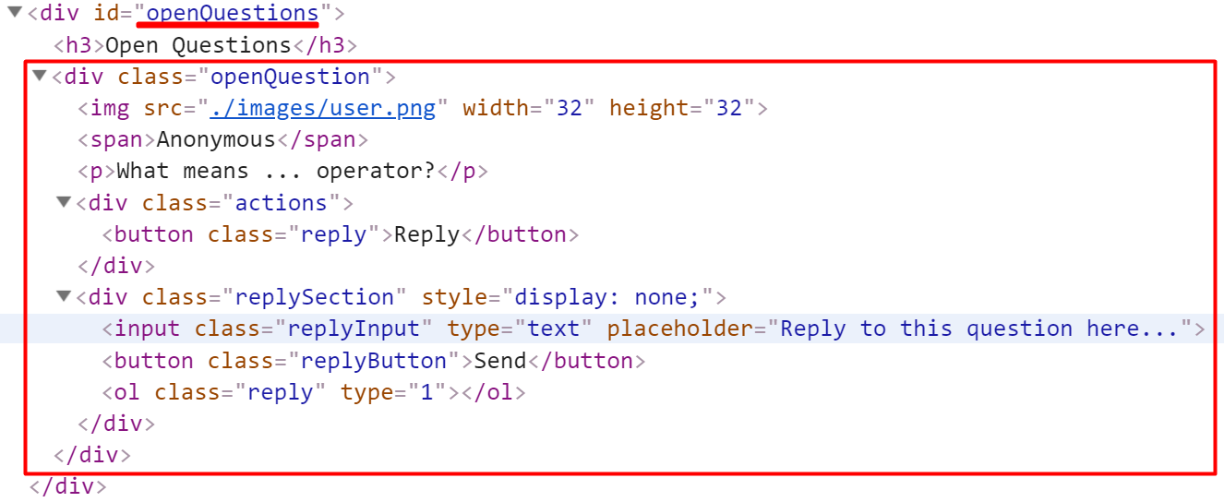

**Keep in mind** when the pending question is moved (appended) to the open questions section, the current question structure should be like the example above (The elements must be created inside the **replySection** but the section should **not be displayed**)

#### [Reply to the question]

By default, every **div element** with class "**replySection**" has **CSS** **styles** which are **property** **display**-**value** **none** (**display: none**), but if some of the [**Reply**] **buttons** are clicked, the current **replySection** must be shown (The **display** **property** must be **changed** to **block** (**display: block**). If the button [**Back**] is clicked again (when the section is displayed), the styles must be changed again to **display:none.**

If the **input** **field** in the "**replySection"** is filled with some text (answer to the current question) and the [**Send**] button is clicked, the current answer (the input value) must be appended to the ordered list (**ol element**) like text content on list item (**li element**)

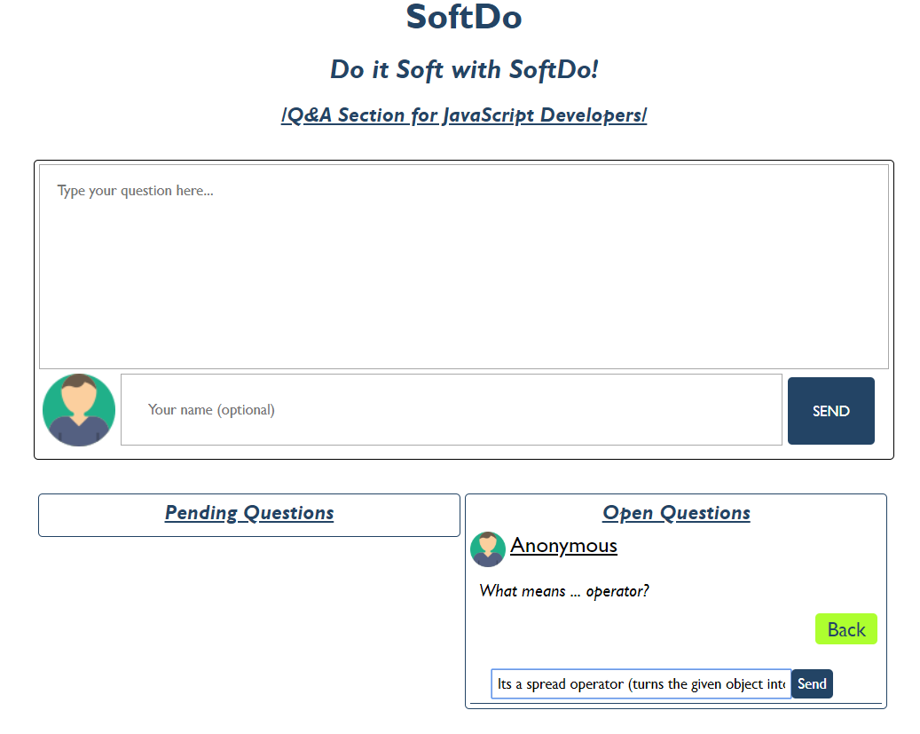

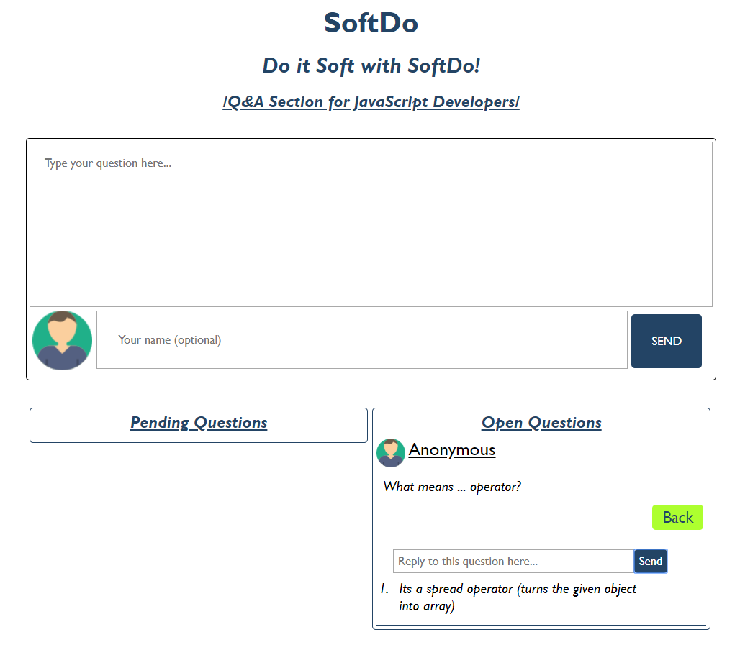

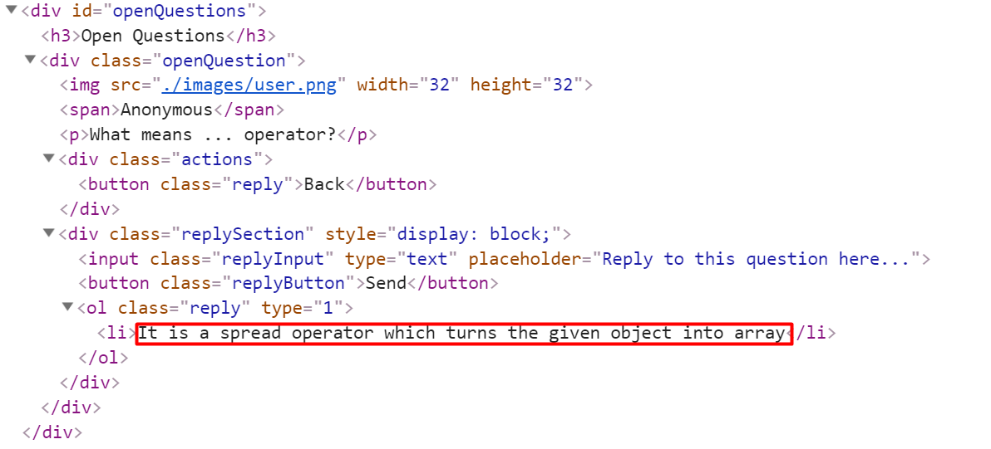

*GOOD LUCK!😊*